**EBS**

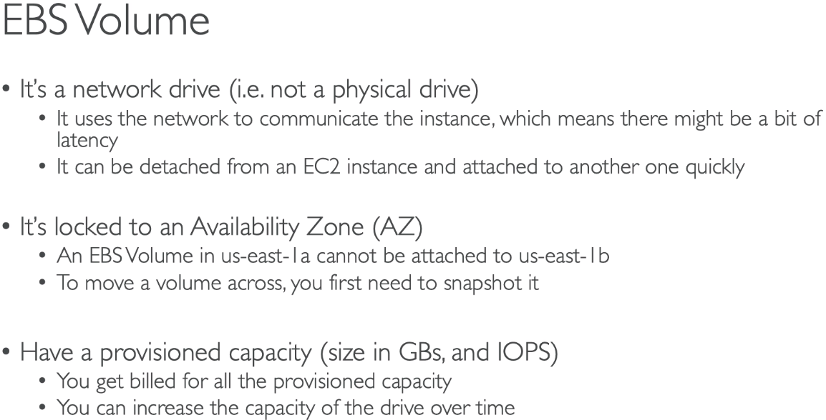

* EBS volumes are locked to a specific AZ
* Automatically redundant (replicated within AZ)

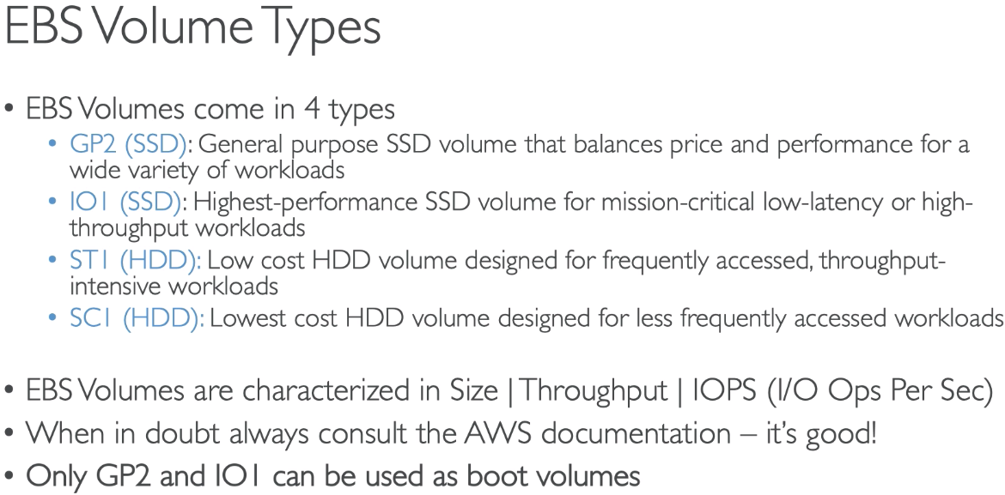

**TYPES:**

* **GP2**
  + For most workloads
  + Boot volumes
  + Burstable IOPS to 3000
  + 3 IOPS per GB, 5TB is the max IOPS
* **IOI**
  + Critical business apps on sustained IOPS performance
  + Large database workloads
  + 50 IOPS per GB, max 32000 PIOPS
* **ST1**
  + Streaming workloads, fast throughput at low price: kafka, big data, log processing
  + Cannot be boot volume
  + Max IOPS is 500
* **SC1**
  + Data infrequently accessed
  + Cheaper, max IOPS is 250

**EBS SNAPSHOTS**

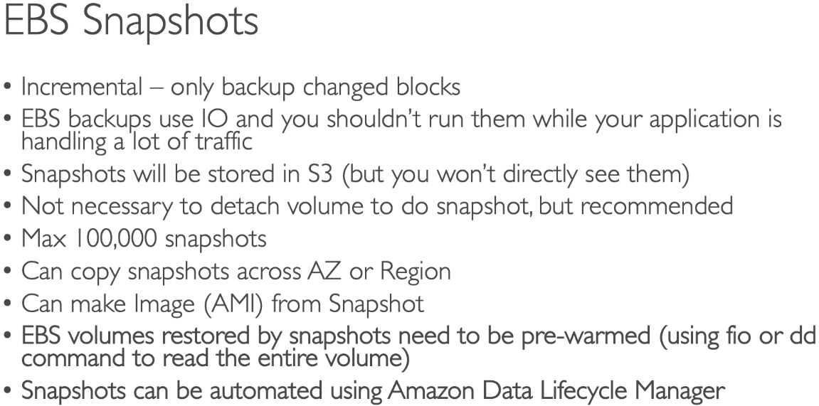

* To migrate a volume:
  + Snapshot the volume
  + Create a volume from the snapshot in some other zone
* To encrypt:
  + Create and EBS snapshot of the volume
  + Encrypt the EBS snapshot
  + Create new EBS volume from the snapshot (volume will be encrypted)
  + Attach the encrypted volume to some instance

**INSTANCE STORE**

* Better I/O performance, good for buffer/cache
* Survives reboot
* Backups must be operated by user
* Cannot resize
* Only certain types of instance type have them

**RAID OPTIONS**

* Possible is OS supports it
* RAID 0 and 1
  + RAID 0: performance up, risk up
  + RAID 1: fault tolerance up, performance down

**EFS**

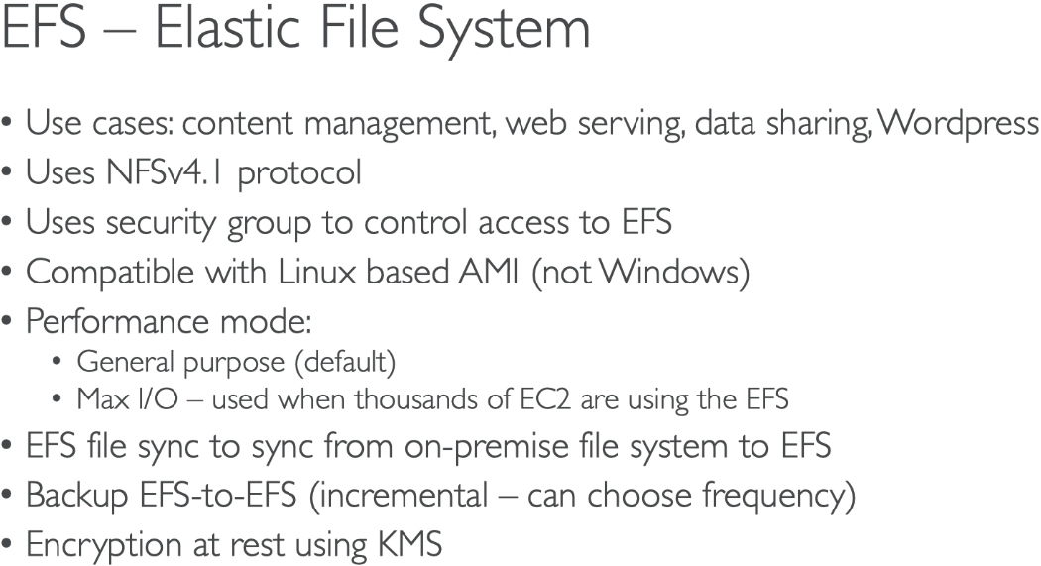

**EBS AND EFS FOR SOLUTIONS ARCHITECT**

